UX Challenge – Design Thinking workshop, Prototype, Presentation for Evolve Tours and Camps.

**Brief**

In your groups

Conduct a Design thinking Workshop utilizing 4 to 5 design thinking strategies for Evolve Tours and Camps for Teacher, Parent and Student personas.

Outline the experience and present the experience as to how you synthesized findings and decided to build the evolve product

Come up with wireframe mock ups and sketches to describe entire flows of the app.

Present your findings to the class and to Daniel Rinzler CEO of Evolve Camps

This assignment is worth 25 points of your final grade

5 marks conducting the design thinking workshop with your group and outline stages of the workshop

5 marks for synthesizing the findings and taking action towards building a product solution

5 marks for creating wireframes and flows of the experience and solution

5 marks for presenting this to the class

App Requirements:

1. The app should have the camp and trip experiences up front for a parent or teacher to access once they login to the product
2. Login and password will be supplied once the user signs up on the evolve website www.evolvecamps.com OR [www.evolvetours.com](http://www.evolvetours.com) – user then will download the app and sign in to the app. With the credentials given to them from signing up on the website. They will receive an email with login info to the camp or tours dashboard.
3. Once entering the app the user should be able to access both camps section and trips section. Your task is to use design sprints and design thinking to define that experience for students, teachers and parents.

CAMP EXPERIENCE REQUIREMENTS – only for Parents persona

1. Your assignment is to take the experience from the Evolve Camps website experience and translate it to a mobile app experience.
2. Each group will have a login to experience the desktop version of evolve camps dashboard for PARENTS:

We have created Evolve Camps's Parent users as follows :

Parent Login URL :-<https://www.evolvecamps.com/campregistration/login>

Username/Email  :- [BK@yopmail.com](mailto:BK@yopmail.com)  
Password :- 2NA2ZE  
  
Username/Email: [Dos@yopmail.com](mailto:Dos@yopmail.com)  
Password: WI5PM4  
  
Username/Email: [Grouper@yopmail.com](mailto:Grouper@yopmail.com)  
Password: JCKM4O  
  
Username/Email: [okboomer@yopmail.com](mailto:okboomer@yopmail.com)  
Password: QF8FRX  
  
Username/Email: [Violentrhinos@yopmail.com](mailto:Violentrhinos@yopmail.com)  
Password: UVZN44  
  
Username/Email: [Jeljo@yopmail.com](mailto:Jeljo@yopmail.com)

Password: 8N3U8Y

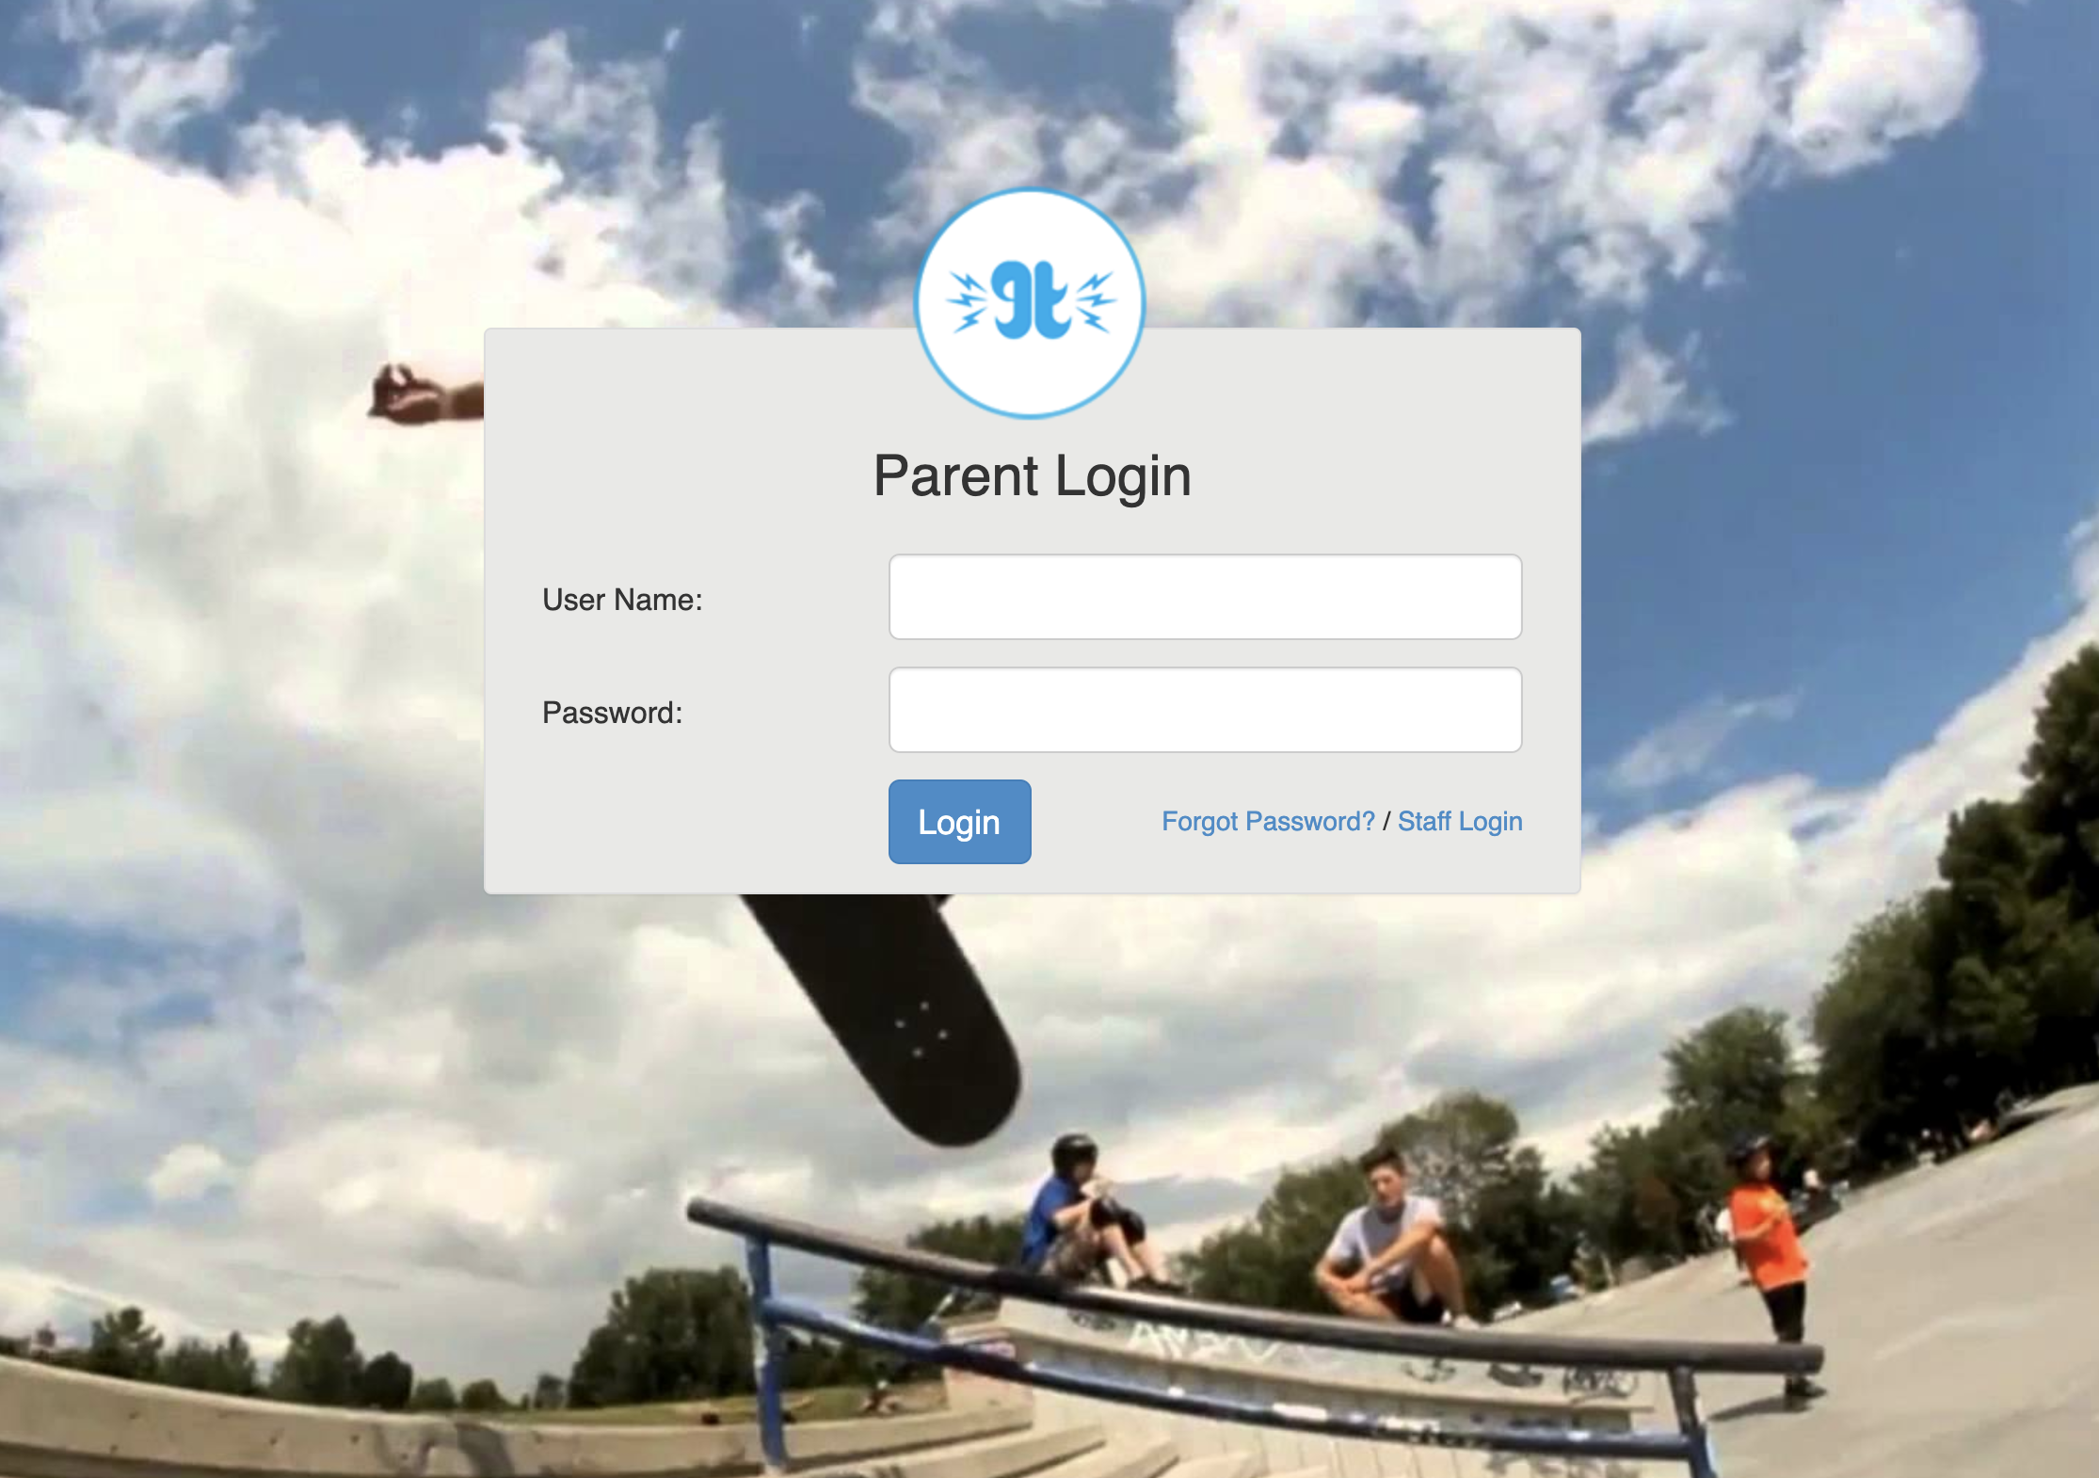

You should see the following screen once you login:

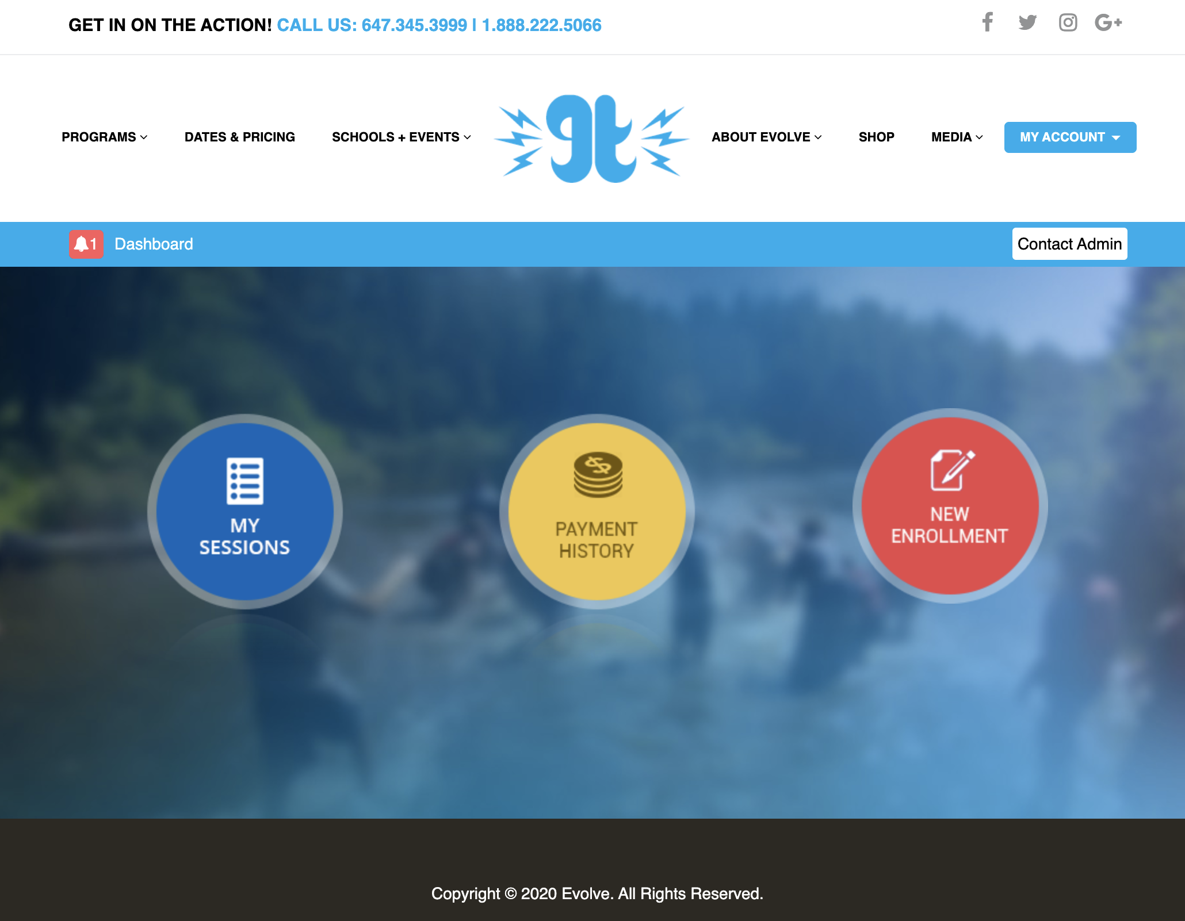

1. Create a login experience for the mobile app – use Evolve camps branding
2. Once the user enters into the camps portion of the app. A news feed experience should be present….your task is to define this news feed experience. For reference check out blogto.com mobile/desktop experience as an idea…try to use your own design thinking to define what this news feed experience should be like. What would be part of the news feed? Use design thinking to define this.
3. Incorporate a chat experience in the app. Use design thinking and sprints to define this chat experience between evolve and the parent.
4. The camp portion of the app should have the following features for the user to experience:
5. **My sessions** – the sessions they are signed up for. Use the website experience to guide you. Make it mobile friendly
6. **Payment history** – use the website experience to guide you. Make it mobile friendly
7. **Camp package** use PDF experience to guide you. Make mobile friendly
8. **Bus schedule** – use bus schedule pdf to guide you: user can select City, week/session#, Bus#
9. **Meal plan** – information page…make it mobile friendly
10. **Gear** – view by skateboard gear, scooter gear, BMX gear, ski gear, snowboard gear, Dos and Donts
11. **Social** – should lead user to Instagram and facebook
12. **Logout**
13. **FAQ**
14. **Terms + Conditions**
15. **Insurance** – user can sign up for session insurance through the app.
16. **Notifications**. User should be able to receive notifications…what would that experience be like?
17. **Community section**…user can create a community topic, post it in the community section – this section allows a user to add topics (which need to be approved by Evolve), chat within the community app…perhaps consider pre-canned topics, what would the most valuable pre-canned topics be?

TRIPS SECTION – ACCESSED BY TEACHERS AND PARENTS.persona

Access PARENT AND TEACHER TRIP SECTION AS FOLLOWS:

<https://evolvetours.com/evolveregistration/login>

Role :- Teacher

Username :- [BK@yopmail.com](mailto:BK@yopmail.com)

PWD :- TE-9MXkhueJ

Username :- [Dos@yopmail.com](mailto:Dos@yopmail.com)

Pwd :- TE-LRY95atW

Username :- [Grouper@yopmail.com](mailto:Grouper@yopmail.com)

Pwd :- TE-TiZcALKj

Username :- [okboomer@yopmail.com](mailto:okboomer@yopmail.com)

Pwd :- TE-oP3oYizp

Username :- [Violentrhinos@yopmail.com](mailto:Violentrhinos@yopmail.com)

Pwd :- TE-ppfFtU2y

Username :- [Jeljo@yopmail.com](mailto:Jeljo@yopmail.com)

Pwd :- TE-8ZrBwSSn

Role should be "Teacher" and you can switch account to the "Parent Dashboard" from the upper right corner.

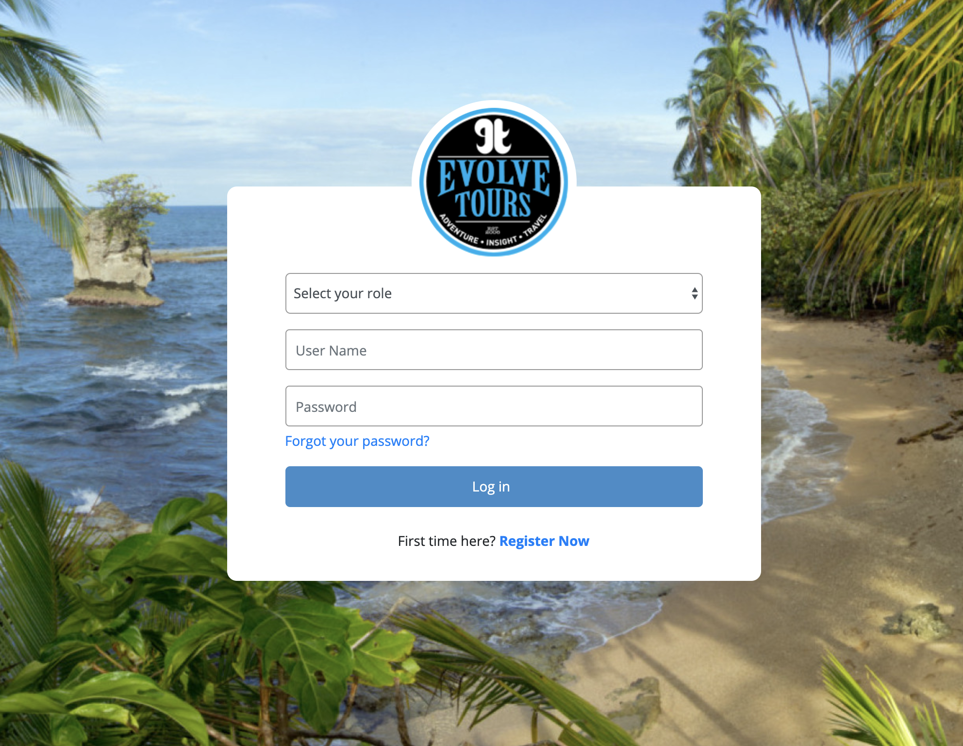

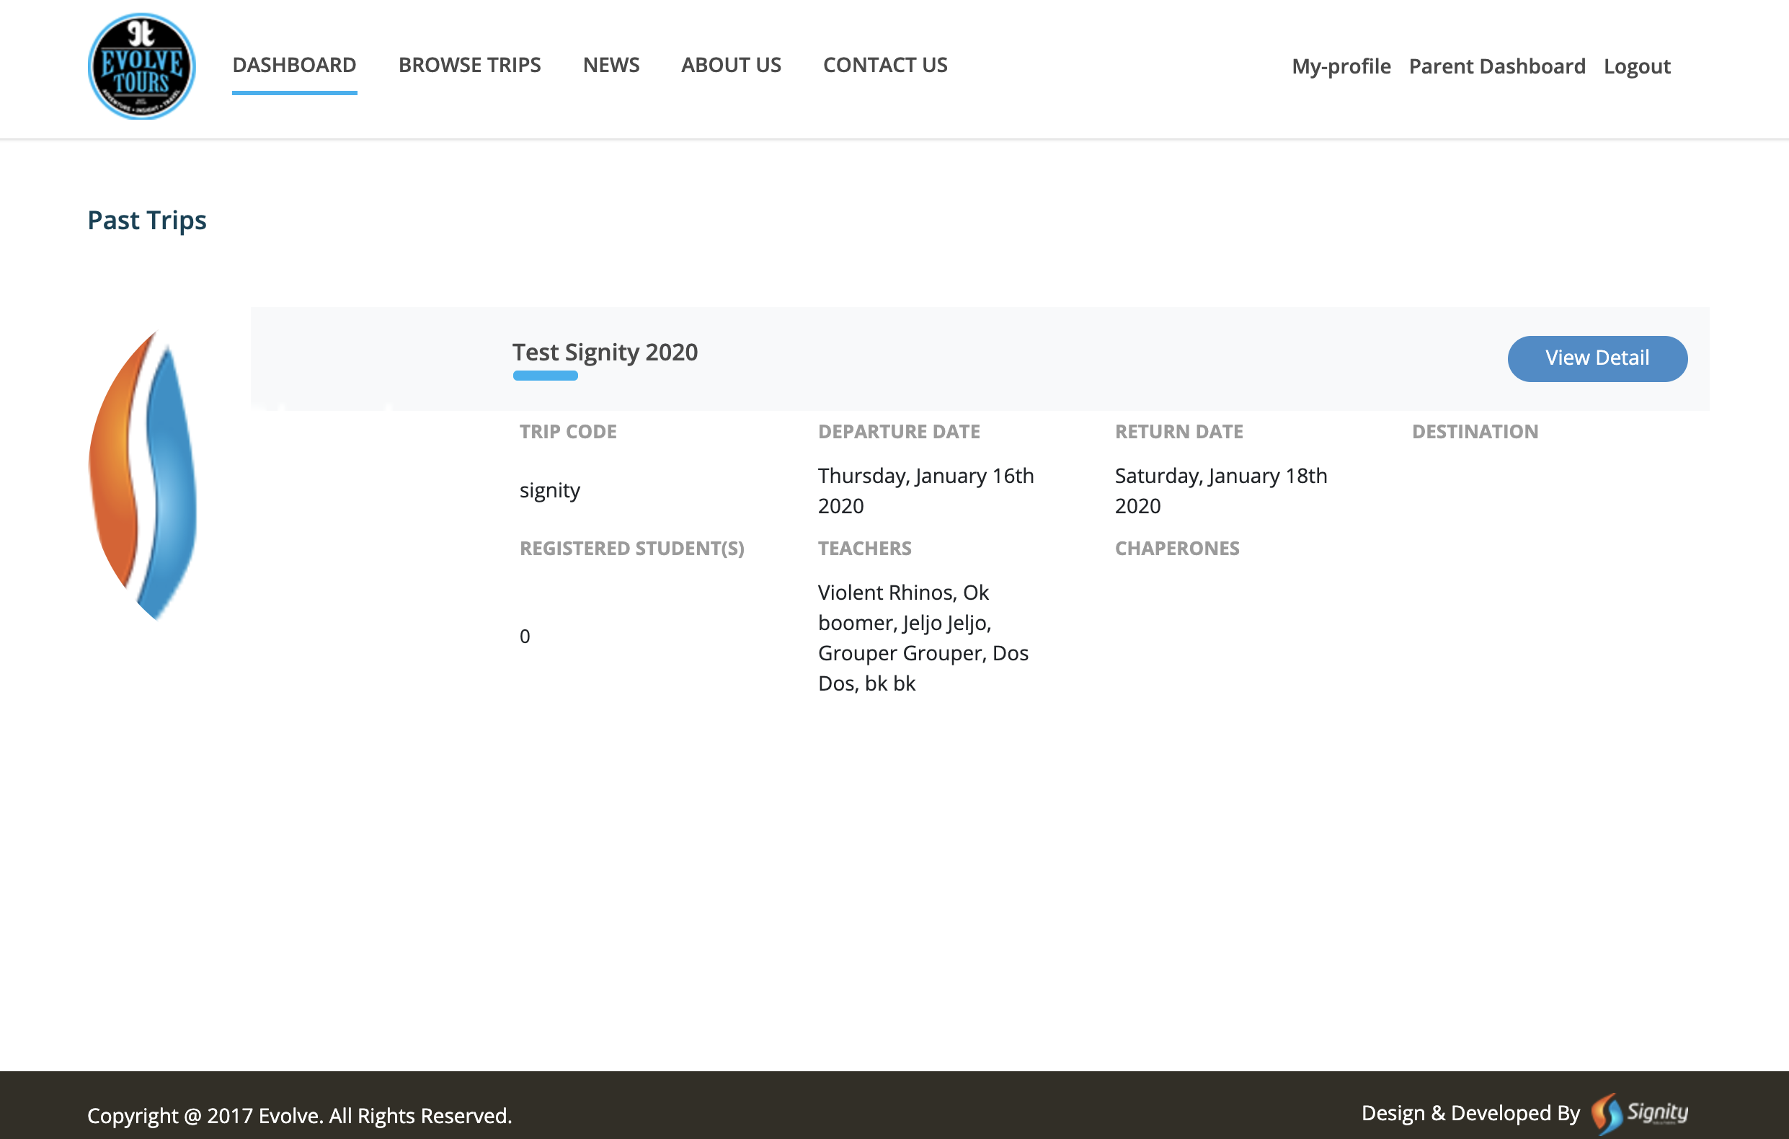

REQUIREMENTS for the mobile app experience:

1. Newsfeed from blog needs to be incorporated.
2. PARENT, STUDENT or teacher EXPERIENCE:

Trip details section

Itinerary

Trip cost

Trip Departure Package

Accommodations

Pre Trip - info to help them prepare for the trip

Post Trip - into to help them “re-enter” from their experience abroad, social actions, community engagement

Destination Info – user can select different regions such as central America, south America Canada, etc. and access specific information to these locations.

Registered Travellers - this button should only be available to teachers, so if you are not a teacher the button doesn’t even appear on the app.

Resources:

<https://careerfoundry.com/en/blog/ux-design/design-thinking-workshop/>

<https://voltagecontrol.co/the-best-design-thinking-exercises-for-any-phase-of-a-project-d4388f0c58cd>

<https://dschool-old.stanford.edu/sandbox/groups/dstudio/wiki/2fced/attachments/f63e8/How-Might-We-Questions-Method.pdf>

<http://www.gregoryschmidt.ca/writing/brainstorm-how-might-we>

<https://www.gv.com/sprint/>

<https://www.ibm.com/design/thinking/page/toolkit>

<https://www.ibm.com/design/thinking/page/toolkit>

<https://medium.com/@diagraam/ideation-strategies-or-how-to-come-up-with-ideas-ec3da7446ac5>

**Deliverables:**

* PDF output, marvel demo, keynote

**Grading Scheme**

|  |  |  |  |  |
| --- | --- | --- | --- | --- |
| Category | Undeveloped | Approaching | Mastery | Exemplary |
|  | **Shows mild level of knowledge** | **Shows moderate level of knowledge** | **Shows proficient level of knowledge** | **Above and beyond expectations** |
| Category | 0-50% | 50-65% | 65-80% | 80-100% |
| Depth of interaction |  |  |  |  |
| Category |  |  |  |  |
| Effectiveness of Solution |  |  |  |  |
| Category |  |  |  |  |
| Craft and Attention to detail | Presentation is not clear or professional | Presentation is clear and professional with some significant issues | Presentation is clear and professional | Presentation is exemplary, clear and confidence inspiring. |
|  |  |  |  |  |
|  |  |  |  |  |